**CLIENT RESPONSE PLATFORM**

**ABSTRACT**

Developing effective mechanisms for feedback collection in learning environments is particularly important at the frontiers of new knowledge .Valuing and asking for feedback has recognised benefits for both staff and students. For Staff to provide information for course design to further develop teaching skills as well as to provide better service to the students. For Students to feel valued and 'listened' to have ownership in their own learning to develop reflective thinking to be better informed in selecting a course/module . The online feedback collection systems, described in this project are two such applications for collecting feedback through a web interface. Intended to support feedback collection in educational environments .ITC – feedback system collects feedback from users about the services offered by for Information Technology and Communication wing (ITC) of NITC. Faculty-feedback system is intended to collect feedback about faculty, from students.

**INTRODUCTION**

Getting the right feedback at right time is of at most importance ,for any organization or faculties of an institution .Getting the feedback from the users will help an organization or faculty to provide better services to the users or students. Ongoing interaction with users can help improve the efficiency of an organization, and enable them to provide better service to the users. Collecting feedback from the users is very important thing for any organization. Until now , feedback collection process is conducted manually, using printed forms. All that has changed with the computer network as well as World Wide Web, making communication far easy .It is very easy to collect feedback about an organization , or about the staff of an institution through a web based system. Valuing and asking for feedback has recognized benefits for both staff and students in an institution. For Staff to provide information for course design to further develop teaching skills to match learning to learners needs to support bids for funding teaching projects For Students to feel valued and 'listened' to to have ownership in their own learning to develop reflective thinking to be better informed in selecting a course/module For All to enhance relationships and define roles to provide a 'positive' teacher/student partnership, which in turn has more chance of ensuring high quality teaching, thereby meeting learners' needs to establish learning objectives, and measure the extent to which they are met to inform executive action, policy developments and resource allocation as part of quality assurance procedure Feedback should be encouraged to be positive as well as giving suggestions concerning areas that could be enhanced. This project aims to develop two online feedback collection systems systems, One system is intended to collect the feedback from users of Information Technology and Communication(ITC) wing of National Institute of Technology, Calicut. Second part of the project is to develop an online feedback collection system for collecting feedback about the faculty , from the students.

**SYSTEM ANALYSIS**

**EXISTING SYSTEM**

The existing method for collecting feedback about the faculty from the students makes use of printed forms on paper. Students write their feedback and submit it to the faculty. This is very time consuming and costly procedure. Preparing the printed form and collecting the forms back from the students is a time consuming procedure. Collecting the feedback from the students about the service offered by ITC is also such a time consuming and difficult procedure.

**DISADVANTAGES OF THE EXISTING SYSTEM**

* Collecting the feedback from the students about the service offered by ITC is also such a time consuming and difficult procedure
* Preparing the printed form and collecting the forms back from the students is a time-consuming procedure.

**PROPOSED SYSTEM**

The Proposed system is a web based system. The user can login to the system with a valid ID and password, fill in an online feedback form and submit the feedback to the system. The administrator can later analyze the feedback.

**ADVANTAGES OF PROPOSED SYSTEM**

* The proposed online feedback collection system is a web based system. So valid users can access it from anywhere.
* This is a platform-independent system. So there is no need for installing any additional software on the client systems.
* The new system issues the users , and asset of questionnaires. The user answers the question and submits this feedback.
* This is very effective, fast and cost-effective method for collecting feedback.
* The users, who give the feedback, are authenticated with a Login ID and password.

**SYSTEM ARCHITECTURE**

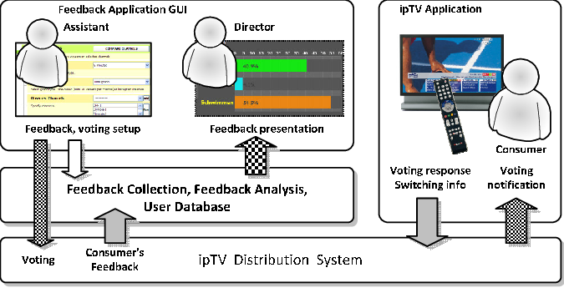

**SYSTEM REQUIREMENTS**

**HARDWARE REQUIREMENTS**

* Hardware: Pentium Dual Core
* Hard Disk: 20 GB.
* Speed: 2.80 GHz
* RAM: 1GB

**SOFTWARE REQUIREMENTS**

* Operating system: Windows 10
* Technology: Java8 and J2EE
* Web Technologies: HTML, Javascript, CSS.
* IDE: NetBeans
* Web Server: Tomcat
* Data Base : MySQL

**MODULES**

* Admin.
* One time customer.
* Regular customer.
* Startup.